Sewa International

**Service to Humanity is Service to the Divine**

### **For Immediate Release**

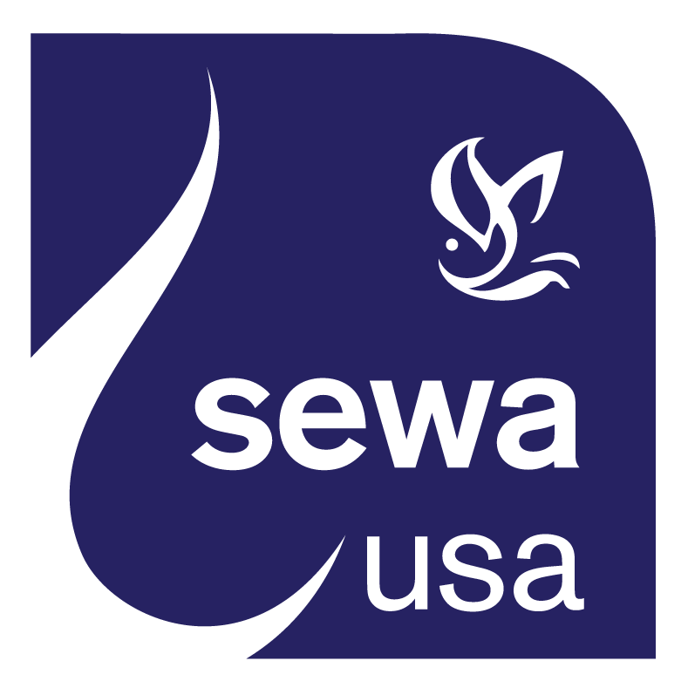

## **PRESS RELEASE**

**CONTACT:**

**Name:** ***Vidya Tontalapur***

**Phone:** 1-720-526-9939

**Email:** [media@sewausa.org](mailto:dr@sewausa.org)

**Web:** www.sewausa.org

#### 

**Sewa International Launches 24/7 COVID-19 Convalescent Blood Plasma Registry**

Houston, Tx (April 11 2020): Sewa International today launched a national registry for COVID-19 Blood Plasma. As of today, the Sewa Plasma Registry ([www.sewacovidplasma.org](http://www.sewacovidplasma.org)) is the only 24/7 service that offers a national registry for both donors and recipients under the Convalescent Plasma Therapy program with live phone and social media support. “Our mission is to bring together matching blood donors and COVID-19 patients seeking the plasma, in-time and save lives, and we are open round-the-clock to serve” said Sewa International President, Prof. Sree Sreenath.

**What is the Convalescent COVID-19 Plasma Therapy?**

Convalescent COVID-19 Plasma Therapy is an FDA regulated investigational therapy where plasma collected from eligible Donors is used as therapy for a restricted class of Recipient Patients, both of whom have compatible blood type.

**Who Can be a Plasma Donor?**

Donor is:

* Male or a non-pregnant female,
* No prior history of Hepatitis B, Hepatitis C, HIV, or intravenous drug use.
* And COVID-19 survivor with either one of the following

1. Complete resolution of symptoms at least 28 days prior to donation

OR

1. Complete resolution of symptoms at least 14 days prior to donation, AND Negative results for COVID-19 either from one or more nasopharyngeal swab specimens or by a molecular diagnostic test from blood.

**Who Can be a Plasma Recipient?**

Recipient is a COVID-19 patient who is acutely ill with respiratory failure deemed to benefit with this therapy after discussion with his or her physician.

Sewa’s registry is a mobile enabled, fully functional, self-registry service with 24/7 live phone and email support that offers both pre-screening and donor-patient matching services. The registry includes status updates and email communication with an automatic status change intimation. Run by a dedicated team of Sewa volunteers, the services adhere to HIPPA medical data protection laws, and protects the privacy and confidentiality of the registered users (donors and recipients). “A dedicated group of physicians and technologists designed and developed this registry rapidly because they saw the urgent need for such a service nationwide,” said Prem Pusuloori, Sewa Director of National & International Programs.

Users of the registry can call **302 659 SEWA (7392)** or contact via email: [PlasmaSupport@SewaUSA.org](mailto:PlasmaSupport@SewaUSA.org).

Convalescent plasma therapy is an investigational treatment under Food and Drug Administration (FDA) regulations (see Box) that physicians use to treat patients with respiratory failure from COVID-19. Results have been encouraging, and more and more physicians are opting for this treatment for their critically ill COVID-19 patients.

Dr.Hari Bogabathina, MD, Board Certified Cardiologist and Interventional cardiology fellow, from Louisiana said, “The medical community worldwide is hard at work developing several investigational therapies. Convalescent plasma therapy was consistently successful in saving patients with favorable risk-benefit profile during prior epidemics like the Spanish Flu in 1918 and the SARS-CoV-1 (older cousin of SARS CoV-2 or COVID-19) in 2003.”

Dr. Bogabathina pointed out that convalescent plasma therapy has been successfully used in current critically ill COVID-19 patients in China and that this investigational therapy has been deployed in the US under FDA guidance. “Early therapy has been found to be beneficial from prior experience with SARS CoV-1. Critically ill COVID-19 patients cannot wait until approved therapies become available. Convalescent plasma therapy unlike several other therapies is available now, only if we can streamline and organize a steady stream of donors who are COVID-19 survivors among us,” he said.

“We at Sewa International are using technology and human resources for troubleshooting regulatory and logistical bottlenecks. We are in a mission to help physicians and families of critically ill COVID-19 patients obtain convalescent plasma in a timely manner,” said Prof. Sree Sreenath.

**About Sewa International**

Sewa International, a leading Indian American nonprofit organization, has extensive experience in disaster rescue, relief, and rehabilitation operations having responded to 24 disasters in the US and abroad. In 2017, after Hurricane Harvey struck the Houston area, Sewa volunteers helped in the rescue of nearly 700 people, and have served thousands of affected families since then through their case management service. Sewa raised over $3 million for Hurricane Harvey recovery, Sewa continues to rebuild houses, and, greenhouses that serve as a means of livelihood. Sewa International has also rendered relief in the wake of hurricane Maria in 2018 and Hurricane Imelda in 2019. Sewa teams in the San Francisco Bay Area continue to build and donate tiny homes for those rendered homeless in California Camp Fire of November 2018.

Among its other accolades, Sewa International has been recognized by Charity Navigator – the premier nonprofit rating agency – as the number five among the “10 Highly Rated Charities Relying on Private Contributions.” Sewa has for the last three years continuously scored the topmost-rated 4-star from Charity Navigator, and has earned perfect scores for its [Financial Health](http://www.charitynavigator.org/index.cfm?bay=content.view&cpid=35) and [Accountability & Transparency](http://www.charitynavigator.org/index.cfm?bay=content.view&cpid=1093).

