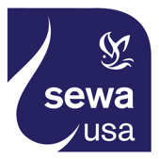

Sewa International

**Service to Humanity is Service to Divinity**

## JOINT PRESS RELEASE

### For Immediate Release

**CONTACT:**

**Name:** Vidyasagar Tontalapur

**Phone:** 1-720-526-9939

**Email:** [media@sewausa.org](mailto:media@sewausa.org)

**Web:** www.sewausa.org

**Sewa International and South Asian Women Physicians of North America Pledge to Work Together to Deal with COVID-19 Pandemic**

Houston, TX (April 20, 2020) – *Sewa International*, a nonprofit Hindu faith-based disaster relief organization, with 43 chapters spread across the United States, and the *South Asian Women Physicians of North America* (SAWPNA), a nonprofit organization comprised of working physicians and physician-scientists, which has 5,320 registered members from all parts of United States and Canada, have decided to collaborate to respond vigorously to the COVID-19 pandemic.

The two organizations released a joint statement:

“We have watched with concern the unprecedented and unpredictable spread of COVID-19, that as of today, April 19, 2020 has infected more than 2.41 million people and killed more than 165,000 people around the world. The rise in infection and deaths has crested in some areas of the world, while it is still climbing in other parts. Much of the world is in some form of a ‘lockdown’, and governments and communities are struggling to put administrative controls in place so that the spread of the virus can be stemmed and that hospitals and doctors are not overwhelmed by the stream of arriving patients and the heavy of load of the sick they have to tend to. Given the nature of this pandemic, and the deep stresses and strains that individuals, communities, cities and states are struggling with, we believe that it is essential, indeed imperative, that we work together to stem the tide of this pandemic, help those who are afflicted to find medical care, and support those who are in some kind of financial or personal distress.

“It is in this context that Sewa International and SAWPNA affirm that the two organizations will collaborate and work together to respond to this pandemic and do as much as we can to alleviate the problems posed by this pandemic.

*“Sewa International*’s 1000+ volunteers over the past six weeks, having set up eight helplines to offer information and resources about travel, health, visas and visa status; delivery of masks to first-responders and those at the frontlines, and delivering food, groceries, and medicines to those who need them; helping seniors in the community  with medical advice, and delivering grocery/meals; helping international students by connecting them to doctors, foreign consulates for helping them with visa and travel updates; assisting stranded students with accommodation needs and food; and providing consultation with doctors and lawyers to those who need them.

“Volunteers have also been busy organizing webinars on a variety of health, wellbeing, travel, business, and other related issues; making and delivering masks; raising funds to buy essential Personal Protective Equipment (PPE) and to help those in distress; networking and collaborating with other community organizations to pool resources and organize delivery of services through a single-point delivery system; and setting up a national convalescent blood plasma registry, the first such, to help those seeking blood plasma transfusion and to enable those who have recovered from the infection to register to donate their blood plasma.

“Sewa International has raised over $500,000 already and seeks to raise $3.5 million to help facilitate this work over the next few months.

“SAWPNA, a unique group that brings together South Asian women physicians and women physician-scientists together, is best positioned to offer important and valid information regarding the nature of the virus, medical response to deal with the virus, and any advances in the research to respond effectively to those who contracted the virus, such as the convalescent blood plasma therapy. SAWPNA will also be able to leverage the information in the plasma registry on a real-time basis and help in connecting donors with recipients through the network of hospitals and laboratories that members of SAWPNA are affiliated with.”

**About Sewa International**

Sewa International, a leading Indian American nonprofit organization, has extensive experience in disaster rescue, relief, and rehabilitation operations having responded to 24 disasters in the US and abroad. In 2017, after Hurricane Harvey struck the Houston area, Sewa volunteers helped in the rescue of nearly 700 people and have served thousands of affected families since then. Sewa raised over $3 million for Hurricane Harvey recovery, including a grant of $400,000 from the Houston Mayor’s Fund, and a $500,000 grant from the American Red Cross. Sewa continues to rebuild houses, and greenhouses, which serve as a means of livelihood. Sewa has also provided case management to affected families more than two years after Hurricane Harvey struck Texas. Sewa International has also rendered relief in the wake of hurricane Maria in 2018 and Hurricane Imelda in 2019. Sewa teams in the San Francisco Bay Area continue to build and donate tiny homes for those rendered homeless in California Camp Fire of November 2018.

Among its other accolades, Sewa International has been recognized by Charity Navigator – the premier nonprofit rating agency – as the number five among the “10 Highly Rated Charities Relying on Private Contributions.” Sewa has for the last three years continuously scored the topmost-rated 4-star from Charity Navigator, and has earned perfect scores for its [**Financial Health**](http://www.charitynavigator.org/index.cfm?bay=content.view&cpid=35) and [**Accountability & Transparency**](http://www.charitynavigator.org/index.cfm?bay=content.view&cpid=1093).

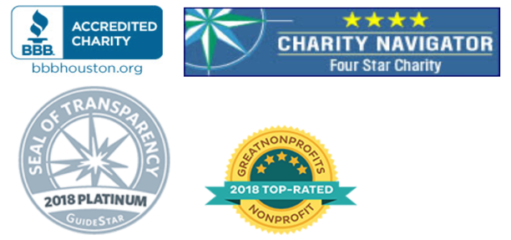

**About SAWPNA**

SAWPNA exists as an organization of international scope that advocates the broad interests of South Asian Women physicians of North America. It encompasses physicians of multiple ethnicities, countries and faiths and is 5320 members strong. The group provides a support system for its members facing domestic violence, physical handicap or loss of family members. SAWPNA provides mentorship for young physicians entering the field of medicine. The group plays a big role in physician advocacy programs and CME talks for physicians. SAWPNA has actively participated in multiple charities such as MANASI project with AAPI and fundraisers for Rohingya and Syrian refugees.