**What is Stop Diabetes Movement (SDM)?**

SDM is a 15-20 hour yoga program designed to help diabetics to control and manage active diabetes. All the yoga practices are safe and proven by research to be helpful in management of diabetes. Trained and certified yoga teachers deliver this program.

**AIM:** Diabetes prevention and control

**OBJECTIVE:**

* **Primary:** Prevent pre-diabetics from diabetes
* **Secondary:** convert severe diabetics to moderate to mild to diabetes free

**RESEARCH EVIDENCE:** About the usefulness of yoga

S-VYASA Yoga University, through 30 years of research has proven that yoga lifestyle can change/impact:

* Normalize blood glucose (Fasting and postprandial)
* Normalize Glycated Hemoglobin (HbA1C)
* Reduce bad cholesterol & Increase good cholesterol
* Normalize weight and BMI & Reduce oral medication
* Reduce anxiety & depression & Improve quality of life

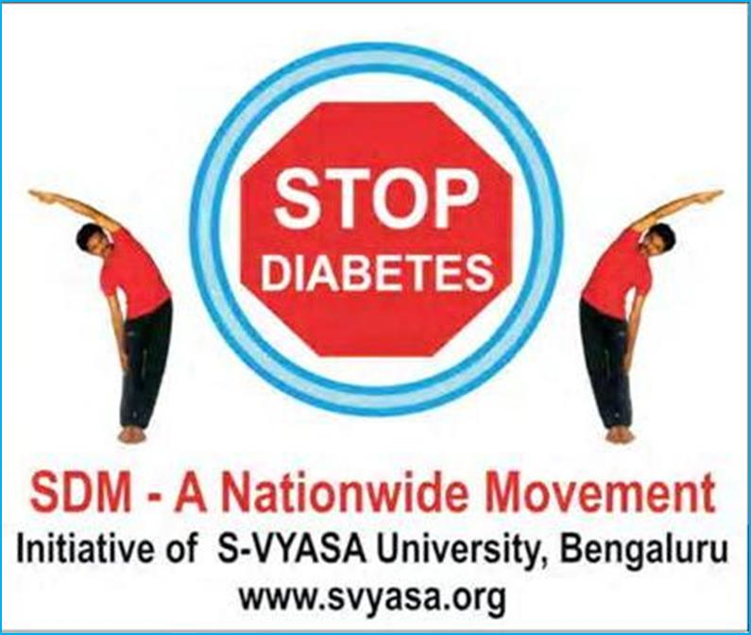

**VENUE: Zoom Link will be sent upon registration**

**Learn Yoga to manage your Diabetes!!!**

**PROGRAM OUTLINE:**

* Yoga postures and stretches
* Yoga breathing and relaxation
* Stress management through yoga
* Diet and nutrition for diabetics
* Attitude and Lifestyle Changes



* **Enroll before November 8th, 2021**
* **Register:** <https://sewausa.org/event-4536339>
* **Email: sewachicago@sewausa.org**

**Yoga Program/Camp Details:**

* **Dates: Fri, Dec 3, 2021 to Sun, Dec 12, 2021**
* **Time – Weekdays 5:30pm - 7:00pm CT**
* **Saturdays & Sundays: 9.00am to 10:30am CT (all 10 sessions mandatory)**
* **Registration Cost: $30, ( includes Yoga For Diabetes book )**

**(100% of the fees is donated to Sewa)**

**Resources available:**

1. **Post Camp - 5 hourly classes every Sunday**
2. **Access to a video for practice sessions**

**Donations can be made at:** [**https://sewausa.org/Donate**](https://sewausa.org/Donate)

**OR via check. (payable to Sewa USA)**

For any questions/assistance, you can email us at: [Sewachicago@sewausa.org](mailto:info-sdm@sewausa.org)

 

Sewa International, Chicago Chapter

***Yoga for Diabetes***

***STOP DIABETES MOVEMENT - SDM***